COFFEE SALES FORCASTING

1. Project Background
The coffee vending machine industry generates large volumes of transactional data on a daily basis. Each transaction provides valuable information about customer purchasing behavior, product demand, and sales performance over time. However, without systematic analysis, this data remains underutilized and cannot effectively support business decision-making.
This project is based on an open coffee sales dataset collected from a vending machine, covering daily transactions from 1st March 2024 to 31st -July-2024. The dataset captures detailed information such as transaction dates, coffee products, payment methods, customer identifiers (for card payments), and pricing. By applying time-series analysis and exploratory data analysis techniques, the project aims to transform raw sales data into meaningful business insights and future sales predictions.

2. Problem Statement
Despite having continuous transactional data, the vending machine operator faces challenges in understanding and utilizing the data effectively. Key business questions such as identifying sales trends, understanding customer preferences, and predicting future demand remain unanswered due to the absence of structured analysis and forecasting models.
The lack of insight makes it difficult to:
- Identify peak and low sales periods
- Understand which coffee products drive the most revenue
- Track repeat customer behavior
- Forecast future sales for better planning and inventory management
Therefore, there is a need to analyze historical coffee sales data and build forecasting models that can provide actionable insights and reliable future sales predictions.

3. Project Objectives
The primary objectives of this project are:
- To perform Time Series Exploratory Data Analysis (EDA) on coffee sales data
- To identify sales trends, seasonality, and patterns over time
- To analyze product-wise sales performance and customer preferences
- To study specific customer purchase behavior using card-based transactions
- To forecast next day, next week, and next month sales using historical data

4. Data Summary :

The coffee sales dataset consists of 1,133 transaction records collected from a coffee vending machine over a period ranging from March 2024 to July 2024. Each record represents a single customer transaction and captures key details related to the purchase.
The dataset contains 6 columns, including transaction date, transaction datetime, payment type, customer identifier (for card payments), coffee product name, and price. All records are complete, with no missing values, indicating successful data cleaning and validation.
Prices are recorded as numerical values and fall within a realistic range, with an average price of approximately ₹33, a minimum of around ₹18, and a maximum of ₹40. This confirms consistent and stable pricing across products.
The dataset includes multiple coffee varieties, with milk-based beverages such as Latte, Americano with Milk, and Cappuccino contributing the highest share of total revenue. Payment behavior shows a strong preference for card-based transactions, enabling analysis of repeat customer behavior.
Overall, the dataset is clean, well-structured, and time-consistent, making it suitable for exploratory data analysis, customer behavior analysis, and time-series sales forecasting.
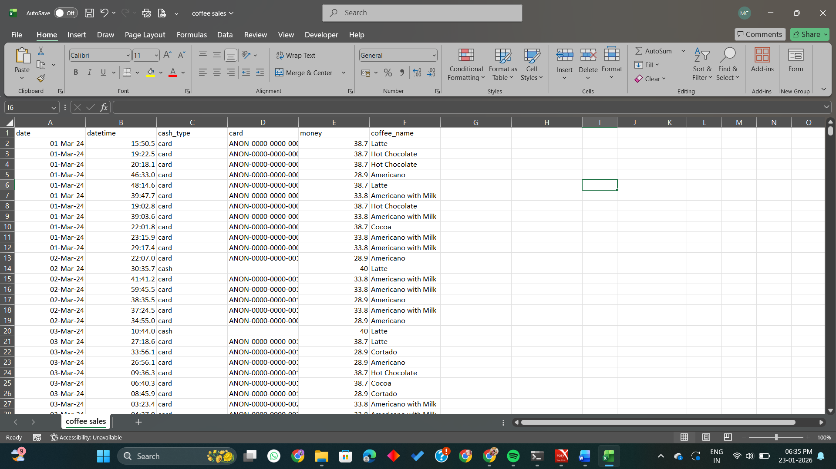

5. EDA [Exploratory Data Analysis]

Exploratory Data Analysis was conducted using Python to understand the structure, quality, and patterns within the coffee sales dataset after completing data cleaning in SQL Server.
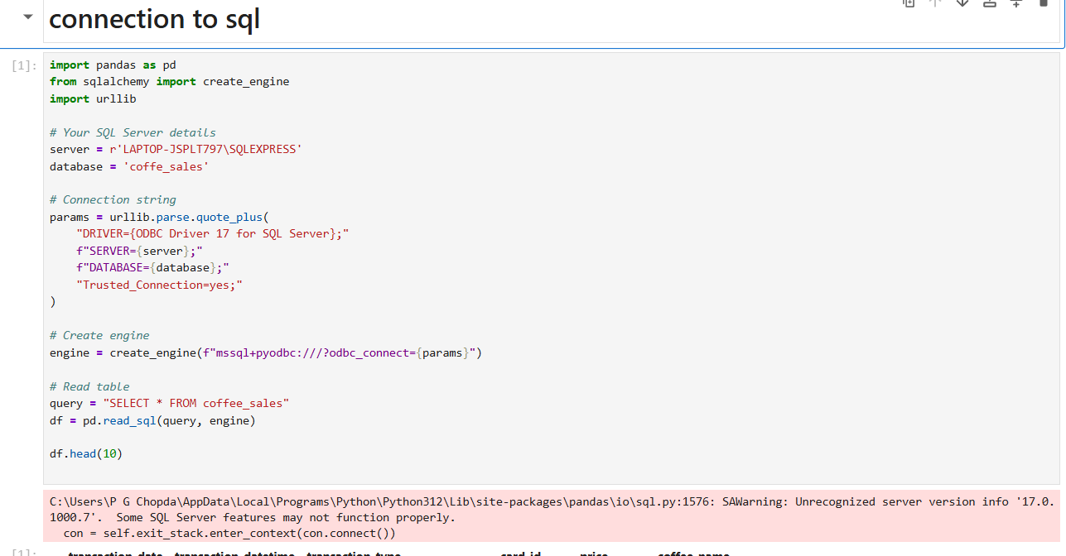
The dataset contains 1,133 transaction records and 6 columns, representing individual coffee purchases made through a vending machine. Initial inspection confirmed that the data was loaded correctly from SQL Server into Python, with all columns containing valid values and no missing data.
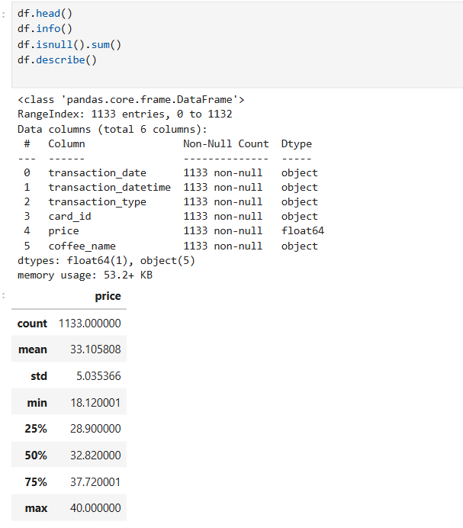
Data type analysis showed that the price column is numerical, while transaction_date, transaction_datetime, transaction_type, card_id, and coffee_name are categorical or text-based fields. This structure is appropriate for both numerical analysis and customer behavior studies. Date fields were further prepared for time-series analysis.
Statistical analysis of the price column indicated that coffee prices are realistic and consistent, with an average price of approximately ₹33, a minimum of ₹18, and a maximum of ₹40. No extreme outliers were detected, confirming stable pricing across products.
Product-wise analysis revealed that Latte, Americano with Milk, and Cappuccino are the top revenue-generating coffee items, indicating a strong customer preference for milk-based beverages. In contrast, products such as Espresso and Cocoa contributed comparatively lower revenue.
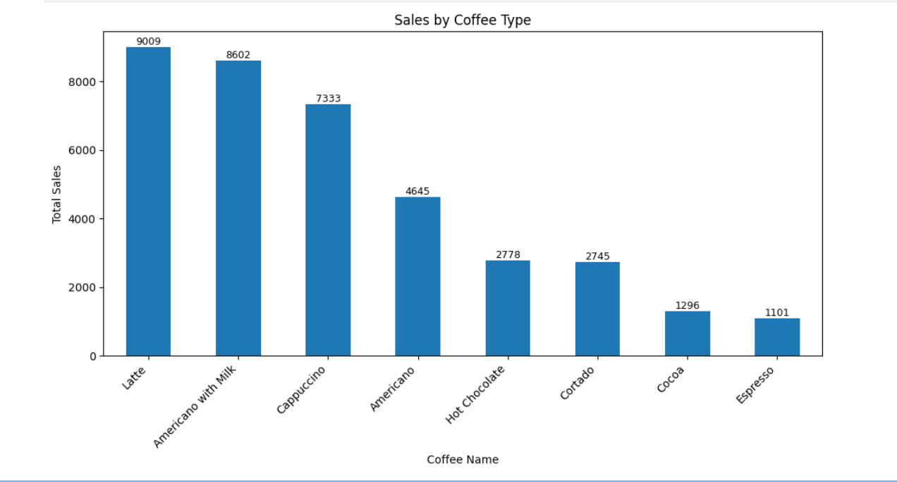
Payment behavior analysis showed a clear dominance of card-based transactions over cash payments. This indicates a strong adoption of digital payment methods and enables tracking of repeat customer behavior using card identifiers.
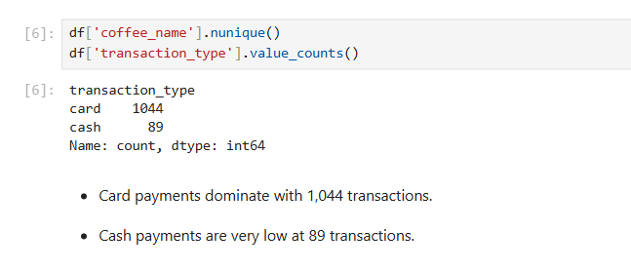
Time-based exploration confirmed that the dataset spans from 01 March 2024 to 31 July 2024, providing sufficient historical coverage for identifying sales trends and performing short-term forecasting.
Overall, the EDA process validated that the dataset is clean, well-structured, and analysis-ready, with meaningful patterns related to product demand, customer payment behavior, and pricing trends. These insights provide a strong foundation for advanced analysis and future sales forecasting.

6.Data Cleaning using SQL

1.How many records are present in the coffee sales dataset?
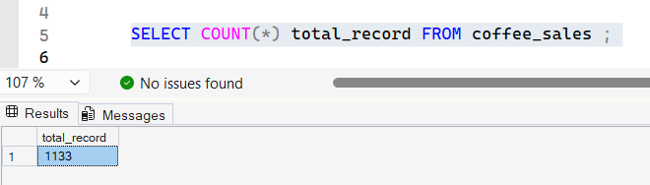
2.What columns and data types exist in the dataset?
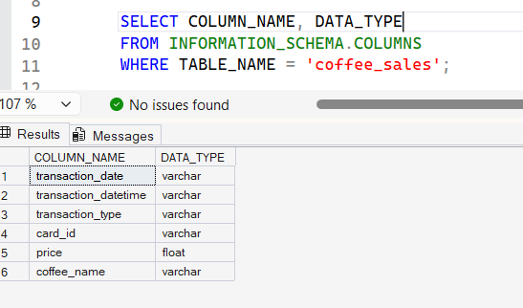
3.How can all column names be changed to more professional and meaningful names?
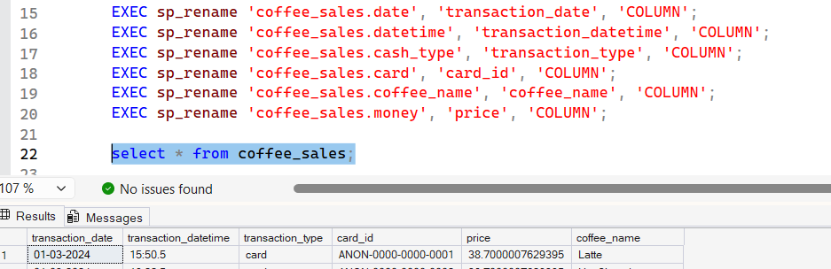
4.Are there any missing (NULL) values in important columns?
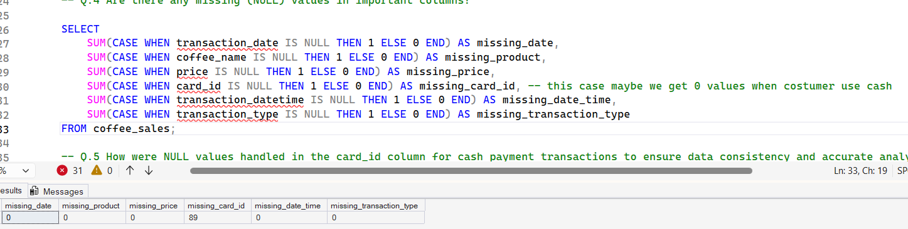
5.How were NULL values handled in the card_id column for cash payment transactions to ensure data consistency and accurate analysis?
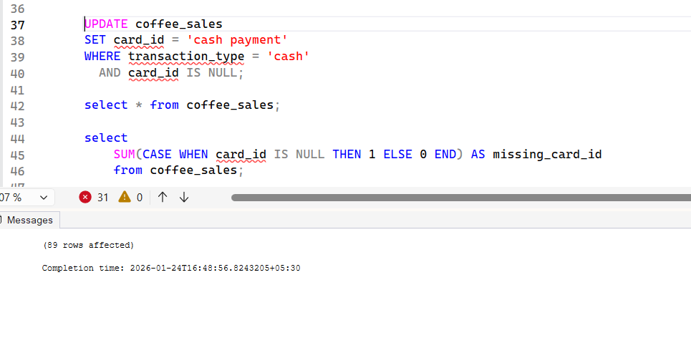
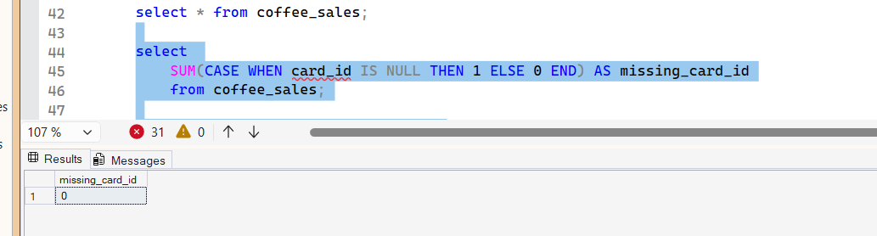

6.Are there any duplicate transactions in the dataset?
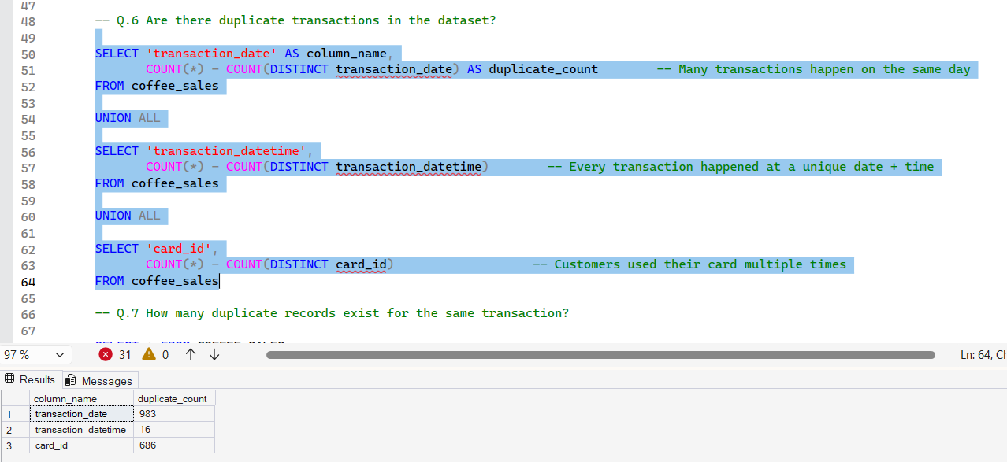
7.How many duplicate records exist for the same transaction (same date and same customer)?
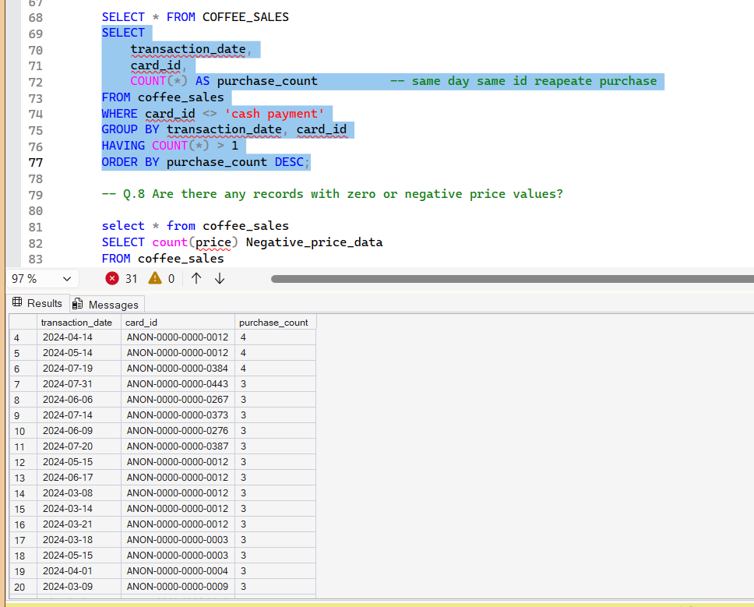
8.Are there any records with zero or negative price values?
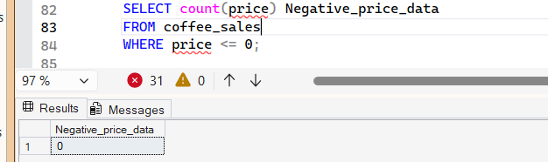
9.Is the transaction date stored in the correct date format?
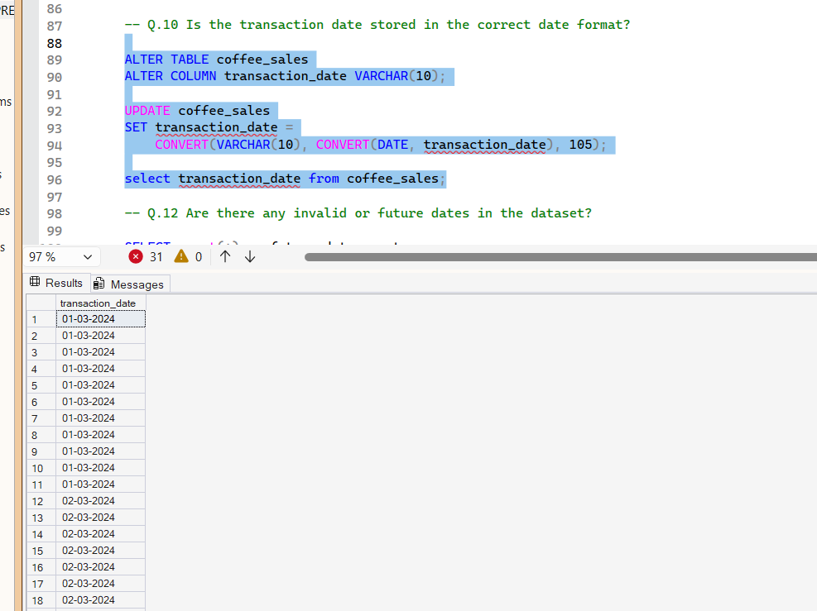
10.Are there any invalid or future dates present in the dataset?
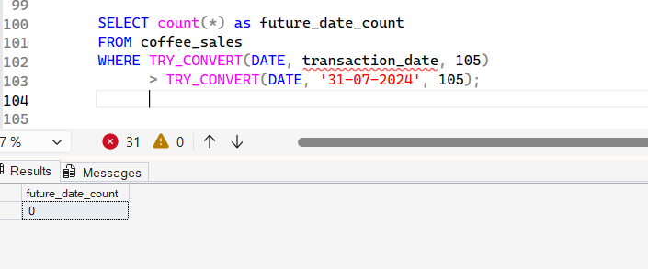
11.Are product names consistent across all records?
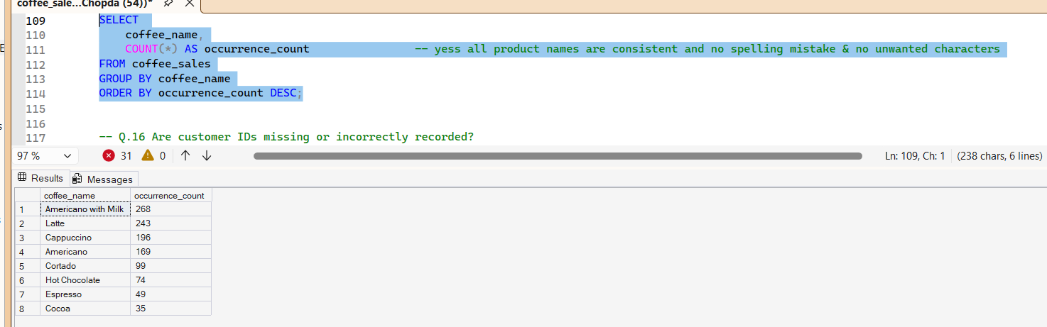
12.Are customer IDs missing or incorrectly recorded?
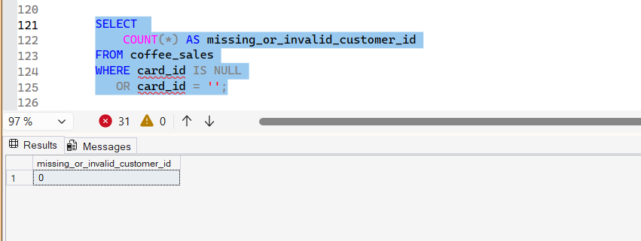
13.Are sales values realistic and within an expected price range?
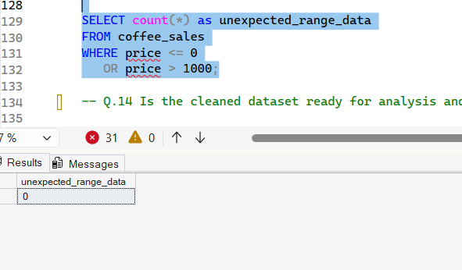
14.Is the cleaned dataset ready for further analysis and forecasting?
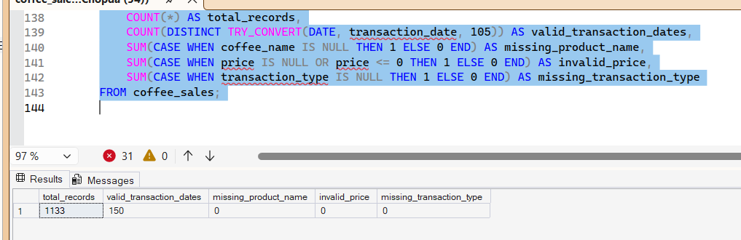

7.Trend Analysis and Seasonal Analysis

SALES BY MONTH
CODE : # visyalize the daily sales trend

import matplotlib.pyplot as plt

daily_sales.plot(figsize=(12,5), title='Daily Coffee Sales Trend')
plt.xlabel('Date')
plt.ylabel('Total Sales')
plt.show()
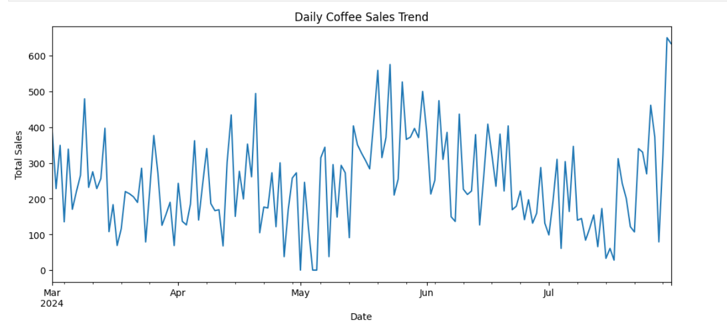
At the beginning of the period, sales remain moderate with occasional sharp increases and drops. In the middle phase, sales activity becomes relatively higher with more frequent peaks, suggesting increased customer usage during certain days. Towards the later part of the dataset, sales continue to fluctuate and include some of the highest daily values.
Overall, the trend indicates active but unstable daily demand, where sales are influenced by short-term factors rather than steady growth. This supports the need for smoothing methods and time-series models to better understand patterns and forecast future sales.
TOP 6 PEAK HOURS
# Top 6 peak hours
peak_hours = hourly_sales.sort_values(ascending=False).head(6)

print("🔥 Peak (Customer-Rich) Hours:")
print(peak_hours)
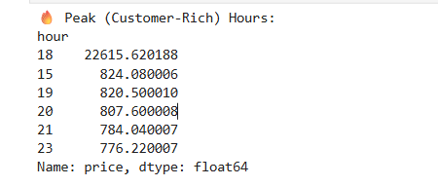
The analysis of hourly sales shows that customer activity is highest during the evening hours. Among all hours, 6:00 PM (18:00) records the highest total sales, making it the most peak hour. Other high-activity hours include 3:00 PM, 7:00 PM, 8:00 PM, 9:00 PM, and 11:00 PM.
This pattern suggests that customers are more likely to purchase coffee during post-work, evening break, and late-night hours. These time periods reflect increased vending machine usage, possibly due to work breaks, fatigue, or social and study-related activities.
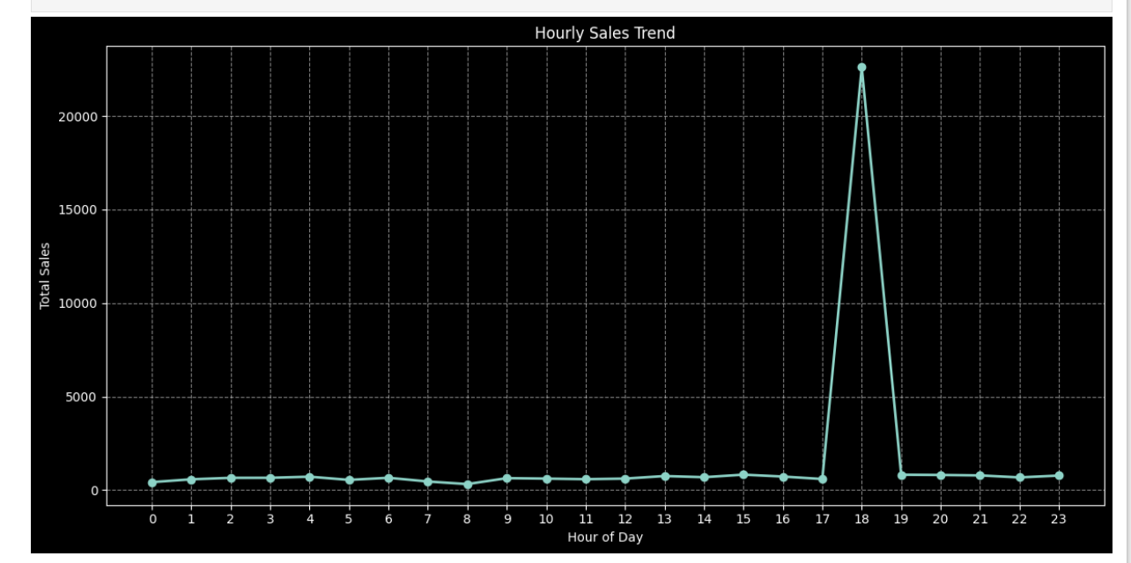

Hour-Based Sales Heatmap Analysis
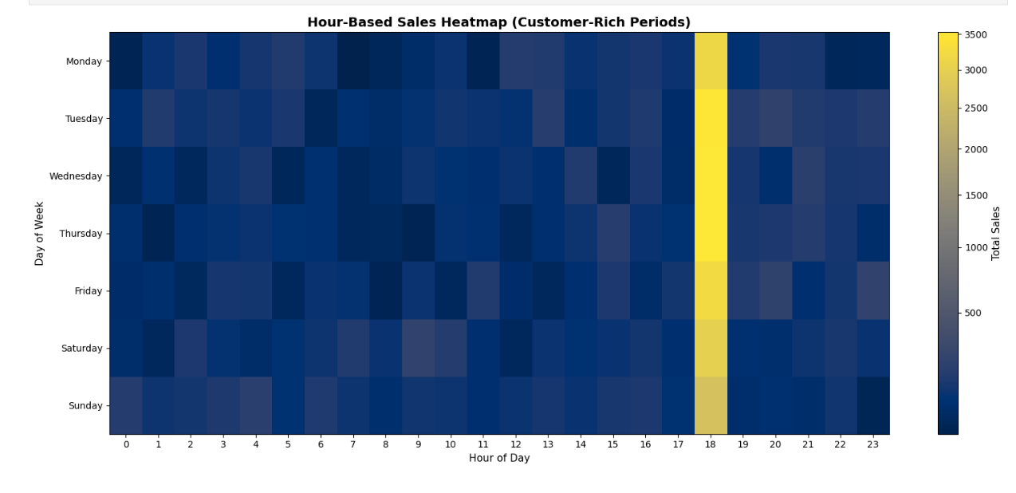
Across all weekdays and weekends, evening hours show the highest sales activity, with 6:00 PM (18:00) consistently emerging as the strongest peak.
The heatmap also shows moderate sales during late afternoon and early night hours, while early morning and late-night periods have relatively lower activity.
Repeat Customer Behavior Analysis
# customer behavior chard user only

repeat_customers = (
df[df['card_id'] != 'CASH']
.groupby('card_id')
.size()
.sort_values(ascending=False)
)

repeat_customers.head(10)
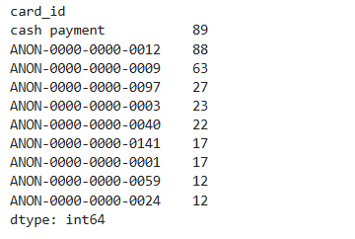
The repeat customer analysis focuses only on card-based users, as card IDs allow tracking individual customer activity. The results show that several customers made a high number of repeat purchases, indicating strong customer loyalty and regular usage of the vending machine.
The card ID ANON-0000-0000-0012 stands out as the most frequent customer, with 88 transactions, followed by ANON-0000-0000-0009 with 63 transactions. Other customers also show consistent repeat behavior, with multiple card IDs recording more than 20 purchases during the observed period.
Monthly Sales Distribution Analysis
The monthly sales distribution shows that coffee sales are spread fairly evenly across the observed months, with some variation. May records the highest share of total sales, contributing approximately 24%, indicating stronger customer demand during this period. June follows with about 21%, suggesting continued high activity.
Sales in March, April, and July remain relatively stable, each contributing around 18–19% of total sales. This balance indicates consistent usage of the vending machine across months, with a noticeable peak in late spring and early summer.
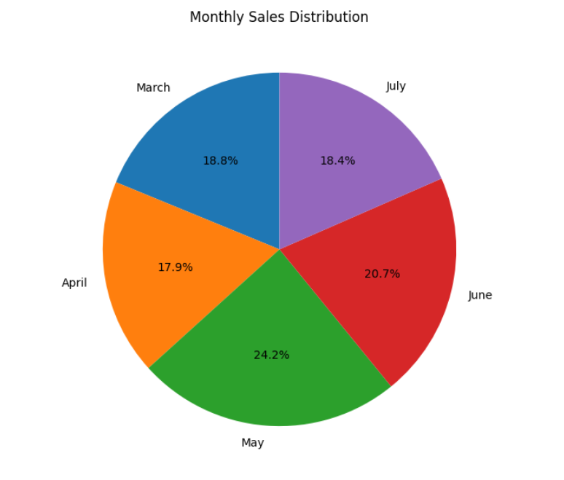
weekly trend 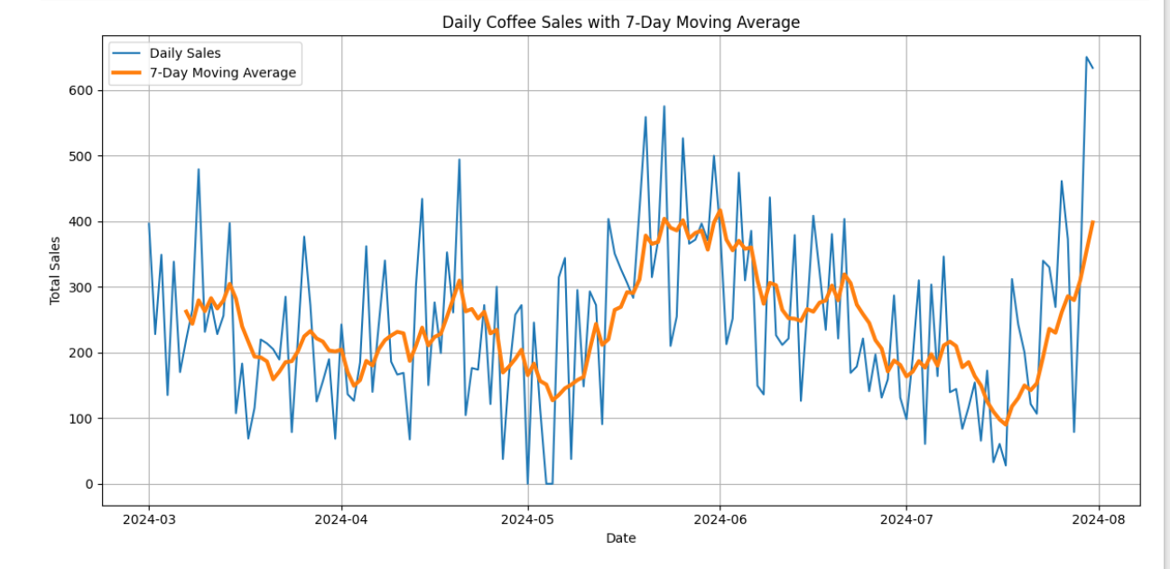

- Sales show a gradual upward trend during the middle of the period, indicating increased customer demand.
- After the peak, the moving average declines, suggesting a temporary drop in sales activity rather than a sudden change.
- Towards the end of the period, the moving average rises again, indicating recovery in sales.
Time-Series Decomposition Analysis – Seasonality
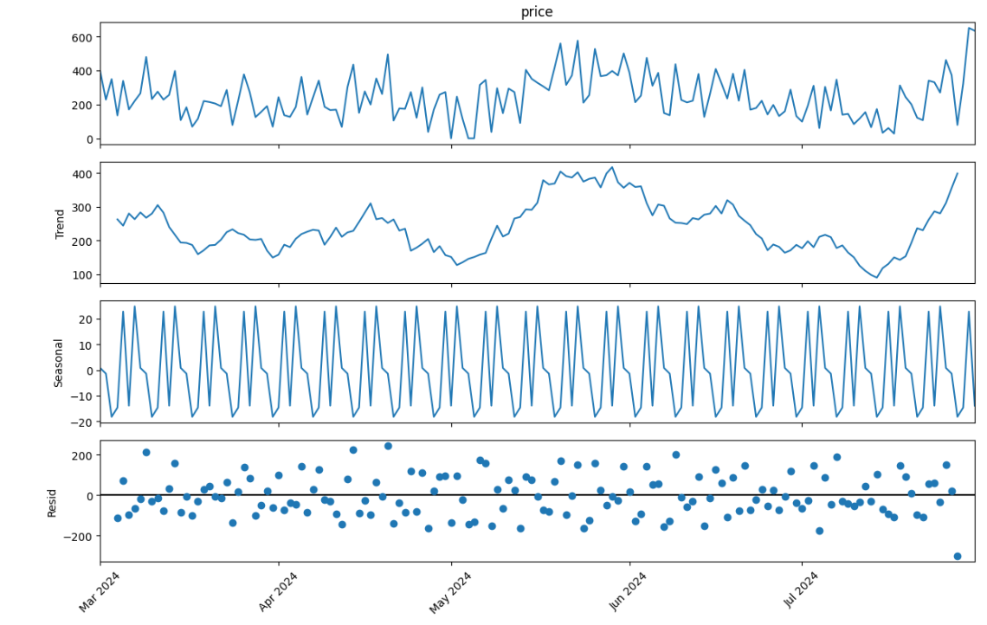
- Observed Component
The observed component represents the original daily coffee sales values. It shows strong day-to-day fluctuations with frequent peaks and drops. This variation reflects real customer behavior, where sales change daily based on demand, timing, and customer activity.
2. Trend Component
The trend component captures the long-term movement in coffee sales. It shows a gradual increase in sales during the middle of the period, followed by a decline and then a recovery towards the end. This indicates that overall demand changes slowly over time and is not random.
3. Seasonal Component
The seasonal component reveals a clear and repeating pattern in sales. The regular ups and downs indicate weekly seasonality, meaning customers tend to follow consistent buying routines on specific days of the week. This pattern remains stable throughout the dataset, showing predictable customer behavior.
4. Residual Component
The residual component represents random variations that are not explained by trend or seasonality. These values fluctuate around zero, suggesting that most meaningful patterns in the data are already captured by the trend and seasonal components.

8.Forcasting using SARIMA Model
1. Prepare the Data
# Visual Inspection of Original Data

plt.figure(figsize=(12, 5))
plt.plot(daily_sales)
plt.title("Daily Sales Time Series")
plt.xlabel("Date")
plt.ylabel("Sales")
plt.grid(True)
plt.show()

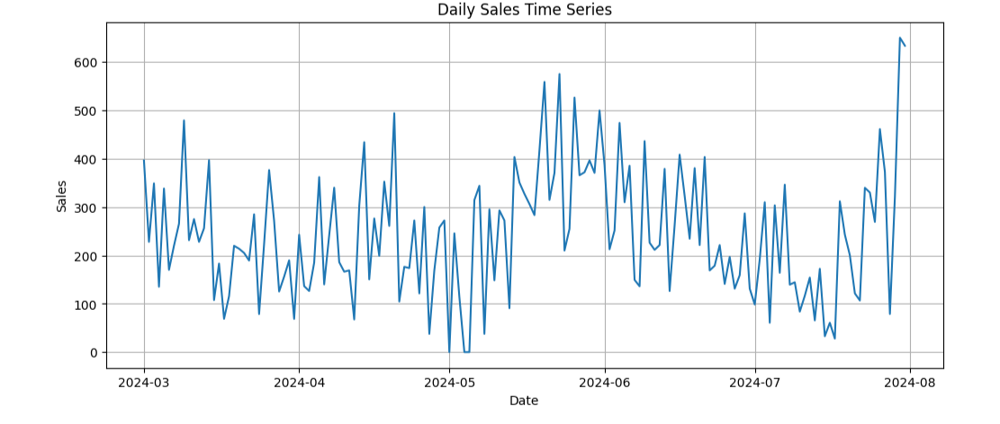

2. Check Seasonality
def adf_test(series, title=""):
result = adfuller(series.dropna())
print(f"ADF Test: {title}")
print(f"ADF Statistic : {result[0]}")
print(f"p-value : {result[1]}")
print("-"*40)

# Conclusion
if result[1] <= 0.05:
print("\n✅ Conclusion: The sales series is STATIONARY (reject the null hypothesis).")
else:
print("\n❌ Conclusion: The sales series is NON-STATIONARY (fail to reject the null hypothesis).")

adf_test(daily_sales, "Original Series")

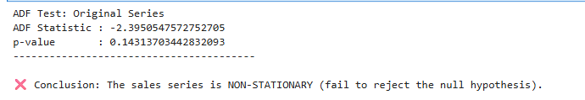

3. Make Data Stationary

sales_diff = daily_sales.diff().dropna()
adf_test(sales_diff, "After First Differencing : d = 1")

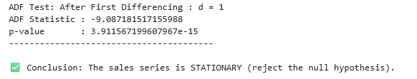

4. Identify SARIMA Parameters

# Seasonal Differencing Check (decide D)
s = 7
seasonal_diff = daily_sales.diff(s).dropna()
adf_test(seasonal_diff, "Seasonal Differencing Check")
print(" "*20)
print("p-value > 0.05 THEN Seasonal differencing NOT required ")
print("-.--."*10)
print("D = 0")

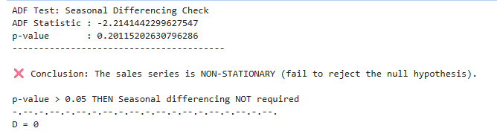

# ACF & PACF (Decide p, q, P, Q)

plt.figure(figsize=(12, 4))
plot_acf(sales_diff, lags=30)
plt.title("ACF Plot")
plt.show()

plt.figure(figsize=(12, 4))
plot_pacf(sales_diff, lags=30)
plt.title("PACF Plot")
plt.show()
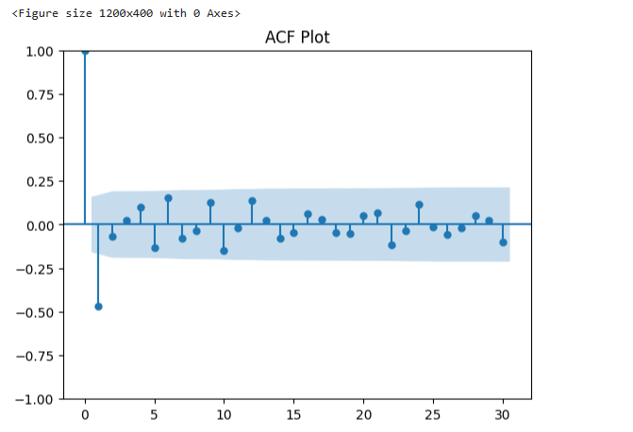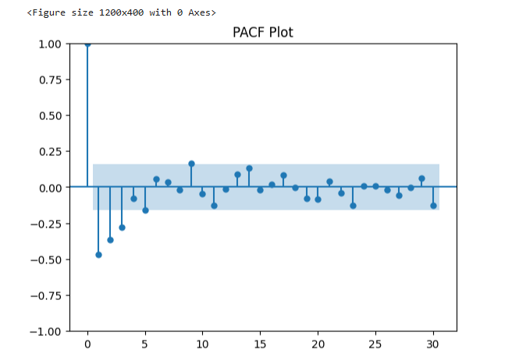
# sarima parameters
p, d, q = 1, 1, 1
P, D, Q, s = 1, 0, 1, 7

5. Build the SARIMA Model
model = SARIMAX(
daily_sales,
order=(p, d, q),
seasonal_order=(P, D, Q, s),
enforce_stationarity=False,
enforce_invertibility=False
)

sarima_result = model.fit()
print(sarima_result.summary())

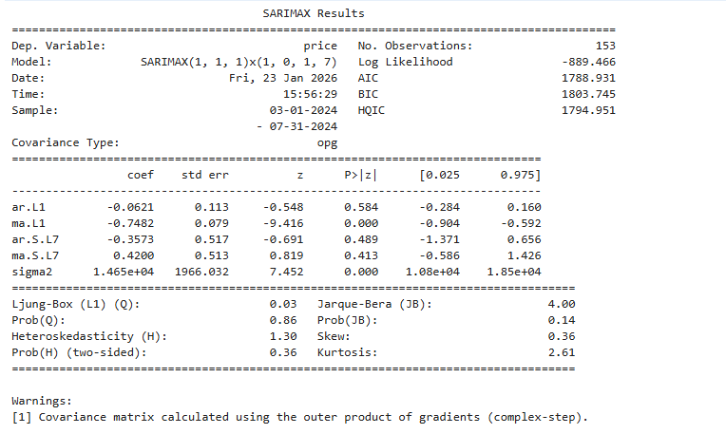

6. Forecast Future Values
# future values

forecast_steps = 14
forecast = sarima_result.get_forecast(steps=forecast_steps)

forecast_mean = forecast.predicted_mean
confidence_intervals = forecast.conf_int()
forecast_df = pd.DataFrame({
'Forecasted_Sales': forecast_mean,
'Lower_CI': confidence_intervals.iloc[:, 0],
'Upper_CI': confidence_intervals.iloc[:, 1]
})

print("\n📈 Forecasted Values (Next 14 Days):")
print(forecast_df)
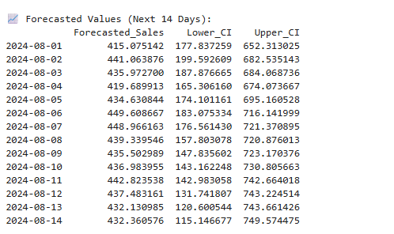

plt.figure(figsize=(16, 10))

# Plot actual historical data
plt.plot(daily_sales, label='Actual Sales', color='blue')

# Plot forecasted values
plt.plot(forecast_mean.index, forecast_mean,
label='Forecasted Sales', color='orange')

# Plot confidence interval
plt.fill_between(
forecast_mean.index,
confidence_intervals.iloc[:, 0],
confidence_intervals.iloc[:, 1],
color='orange',
alpha=0.3,
label='Confidence Interval'
)

plt.title('SARIMA Forecast: Actual vs Forecasted Sales')
plt.xlabel('Date')
plt.ylabel('Sales')
plt.legend()
plt.grid(True)
plt.tight_layout()
plt.show()
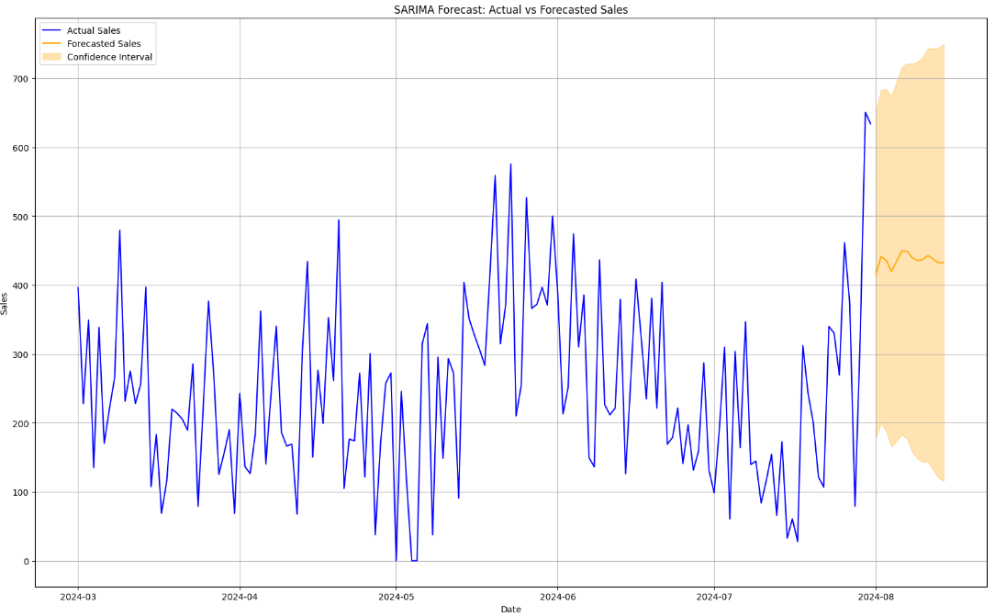

9.Busienss Recommendation
1. Sales are time-driven, with peak demand during evening hours (around 6:00 PM), requiring focused stocking and maintenance planning.
2. Milk-based coffee products dominate revenue, making them the highest priority for inventory, promotion, and visibility.
3. Repeat customers contribute significantly to total sales, highlighting strong loyalty and the need for reward or loyalty programs.
4. Weekly seasonality is consistent and predictable, enabling demand planning based on routine customer behavior.
5. Sales trends are cyclical and forecastable, supporting the use of time-series models for short-term inventory and demand forecasting.

